# Executive summary

This report will cover the financial analysis of the USA-based company Walmart. The report will cover topics such as corporate governance, analysis of financial statements, capital structure, and future investments. And all of this is to understand and realize how the company operates from a financial aspect.

The importance of this report is to understand the corporate finances via the case of Walmart and understand why and how it is attractive to public investors to invest in this company. Since Walmart is one of the biggest retailers in the USA market with 2.3 million employees around the world. And this report might provide information about the company for the students who might work or do internships at Walmart.

Since Walmart is a relatively big company, from first sight to the balance sheets, income statements, and cash flow statements it might seem that the company is making huge profits, however, it is the opposite. Almost at every financial, liquidity, and turnover ratio, Walmart is below the market’s average. While the company’s revenues are ~500 million, which is the biggest revenue in the world for a publicly traded company, their costs are almost at the same level, which indicates low profitability of the company which results in low profits, which is reflected at ratio analysis as well.

Table of Contents

Executive summary 2

Introduction 5

Company profile 5

Corporate governance analysis 6

Selection method of the board of directors 6

Decision making method in board of directors 6

Supervisory method over management team 6

Ethics and transparency inside the firm 7

Applicable laws and regulations 7

Advantages and disadvantages 7

Recommendations 8

Financial Statement Analysis 8

Financial ratios analysis 8

Liquidity ratios 8

Financial leverage ratios 9

Turnover ratios 10

Profitability ratios 11

Market value ratios 11

Comparison with main competitors 12

Capital structure analysis 16

The cost of equity 16

The cost of debt 16

The Firm’s WACC 17

Comparison 18

Preferred method of financing 18

Walmart’s advantages – using debt 19

Future investments 19

References 20

Appendices 22

Appendix A – Market comparison – Financial statement analysis 22

Appendix B – Balance Sheets – Financial Statement Analysis 24

Appendix C – Income Statements – Financial Statement Analysis 25

# Introduction

The purpose of this paper is to better understand Walmart’s finance practices by applying corporate finance theories. This report first analyzes corporate governance and gives possible recommendations. As well as have the advantages and disadvantages of these corporate governances been mapped and analyzed. Analytic ratios, over a time span of three years, were used to better understand the company’s financial performance in the financial statement analysis part. The ratios were then compared with Walmart's competition to better understand their relative position in the industry. You can as well find a common-size analysis of Walmart’s balance sheets and income statements in the financial statement analysis, accordingly with interpretations.  
The capital structure has been analyzed resulting in an overview of multiple cost-posts of Walmart.  
These cost-posts are as well analyzed of Walmart’s competition and the industry average.  
In conclusion of the capital structure a preferred method of financing has been mapped plus the according advantages towards Walmart.  
This report ends with an examination of the future investments of Walmart and its selected methods.

# Company profile

Walmart is an American retail corporation that operates in 24 countries. The company operates approximately 10,500 stores and clubs around the world. It has an e-commerce website. Walmart is headquartered in Bentonville, Arkansas. 2.3 million people are employed at Walmart with 1.6 in the U.S. alone. The business strategy of Walmart is cost leadership as their motto is “Every Day Low Prices on a Broad Assortment - Anytime, anywhere” (corporate Walmart, 2022). Walmart is the biggest company in the world when it comes to revenue (559 million of U.S. Dollars) (Statista). The first Walmart was opened by Sam Walton in 1962 in Rogers, Arkansas. After 5 years of operating the company had already 24 stores with revenues of 12.7 million U.S. dollars (corporate Walmart, 2022).

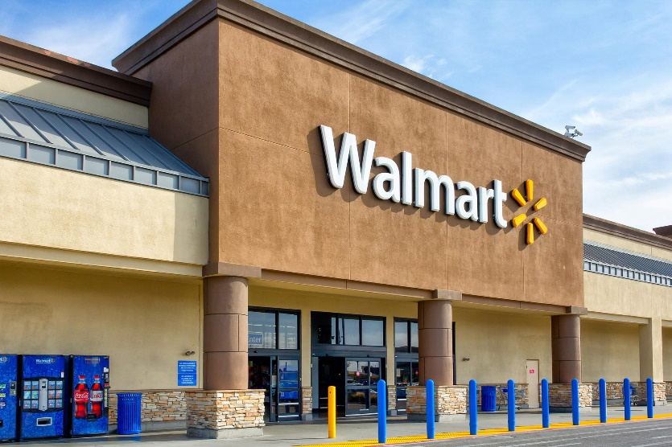

# Corporate governance analysis

Corporate governance is an essential part of every company. According to (Chen, Corporate Governance Definition: How It Works, Principles, and Examples, 2022), corporate governance is a system of rules, practices and processes that have a direct influence on the way a company operates. Corporate governance makes a company transparent, which builds trust towards the investors and gives them an idea of the company’s direction. Walmart's corporate governance has been analyzed to better understand the company's structure and objectives.

## Selection method of the board of directors

Walmart, when deciding on its board of directors, focuses mostly on independent members which means that they are not connected to the company in any way, independent directors should make up more than a half of the whole board. Walmart also has an attention on diversity, both gender and racial. Future directors are also expected to have a great amount of experience and that they understand the business environment. Directors are selected by using voting system.

## Decision making method in board of directors

Walmart operates in a rapidly changing industry of retail therefore constant oversight of overall business strategy and close work with management is needed. To improve the effectiveness of the board’s oversight function, small committees have been created to focus on specific areas. The board regularly reviews its structure and responsibilities to ensure effectiveness. The goal of the decisions is to create long-term value for its investors and manage possible risks that Walmart could encounter.

## Supervisory method over management team

Walmart’s management aim is to provide a holistic assessment of supervisory measures. By outlining the effective performance based on operational management. It applies to the decision-making to prioritize the strategic significance of different approaches. Walmart approach for the board and management is to oversight the strategy, risks and opportunities.

For Walmart to secure an effective management, the board of directors is composed of 16 members, 2 of them are family members of the Walton Family and 2 business executives.

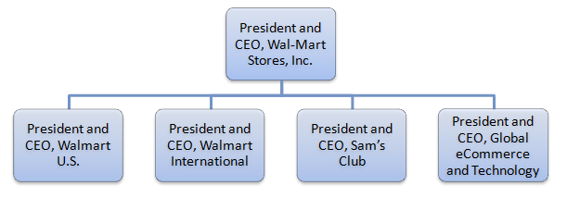

Figure 1: Walmart organizational structure

The top executives and presidents are the connection between the employees and the executives underneath presidents and CEOs to the president and CEO, Walmart Inc.

## Ethics and transparency inside the firm

Walmart trusts in integrity within the firm and aims for the highest standards of ethics. With this trust Walmart's approach to this is creating a culture where they inspire their associates, with their customers and the community with honesty, fairness, and a complaint workplace. This creates a long-term value for society, especially setting multiple compliance program foundations to develop different standards and maintain compliance, training, controlling, and monitoring for and responding to issues.

By prioritizing building trust with associates and the business can ensure that everything including discrimination and harassment won't be tolerated. The code of conduct supports the criteria of the behavior expected.

It reflects:

* Respecting the individual
* Serving the customer
* Striving for excellence
* Acting with integrity

This reflects human rights, environmental protection, and equal opportunity to ensure our dedication to a safe community and transparency inside the firm.

The program foundations of Walmart that is keeping these reflections consistent and responsive is through: Leadership, risk spotting and assessment, standards and controls, training and awareness and monitoring and response.

## Applicable laws and regulations

Walmart remains committed to comply with all applicable laws and regulations. To remain updated with the policies each year Walmart’s licensing compliance group secures more than 209,000 licenses/permits to keep the corporate running. Walmart’s licensing compliance team continues to monitor legislative trends.

These employment compliance obligations are being enhanced in the reinforcement.

Each employee is obliged to follow the laws and regulations in accordance with the applicable laws prescribed which they need to interact with, if not then it will not be tolerated because it will be seen as plead ignorance of the law.

## Advantages and disadvantages

The advantages and disadvantages of the Walmart’s current corporate governance:

The board of directors is selected with a focus on independent members, it is advantageous to Walmart because the board then fairly and objectively directs the company's operations. Walmart also prioritizes trust and respect; it is beneficial to the company, but personal relationships might be harmful to the company’s well-being. One-tier system ensures quick decision making and lets the non-executive board members have a better understanding and more involvement in decision making process. The problem is that executive board members are considered to be more independent than the rest of the board.

## Recommendations

It is recommended that Walmart doesn’t change its current corporate governance methods, the already used way of selecting board members might be improved by decreasing the number of board members chosen by personal relationships. Higher diversification and focus on independent members with great knowledge about retail business might be beneficial as it could improve the quality of decisions.

# Financial Statement Analysis

To create or enforce a deep internal and external understanding of an organization's financial situation, an analysis of its financial statements is a necessity. This analysis allows an organization to gain insights into its financial position, liquidity, profitability, risks, solvency, efficiency, operations effectiveness, and proper utilization of funds (Banerjee, 2022).

In this report, centered around the US giant Walmart, we have zoomed in several financial ratios of the company that occurred in the years of 2019 – 2021. The analyzed ratios are liquidity ratios, financial leverage ratios, turnover ratios, profitability ratios, and market value ratios. These can be found below. Accordingly, we have reflected on the outcomes of these ratios, with a focus on the change of these ratios over the last years. After this component you can observe a comparison of Walmart’s ratios towards its main competitor and the industry as an average.

This financial analysis will end with a comparison of Walmart’s balance sheets and income statements over these years, and what information can be drawn from the found data. This has been realized by utilizing a common-size analysis.

## Financial ratios analysis

Liquidity ratios  
The liquidity ratios are used to determine the ability of the organization to turn its assets into cash or cash equivalents fast and cheaply as quickly as possible. This shows the ability to cover the firm’s short-term debts without raising capital. Most common ratios are *Current Ratio, Quick Ratio, Cash Ratio.* The last 3 years for Walmart were stable, with a small decrease in 2020, because of the pandemic crisis. However, 2021 was recovery year, and on average all three ratios grew by 65,95%.

|  |  |  |  |
| --- | --- | --- | --- |
| **Ratios** | **2019** | **2020** | **2021** |
| Current Ratio | 0,80 | 0,79 | 0,97 |
| Quick Ratio | 0,23 | 0,22 | 0,49 |
| Cash Ratio | 0,10 | 0,12 | 0,19 |

Current Ratiocompares a company’s ability to cover current liabilities. Simply, it grades how fast a company can cover current liabilities by using current assets (Fernando, Current Ratio Explained With Formula And Examples, 2022).

Quick Ratiois strongly similar to the current ratio. The change is within the fact that the quick ratio only looks at highly-liquid assets or cash equivalents into consideration. The current ratio takes all current assets and liabilities on board in its calculations (Folger, 2022).

The Cash Ratio, yet again, is a similar ratio. The cash ratio only uses cash and cash equivalents in comparison to the current liabilities.

We interpret this data as highly positive. We can observe a (very) small decrease for the current and quick ratio’s in 2020, these are strongly gone when we take a look at 2021. Herewith we see all the three ratio’s with a significant increase. 2020 is the known year that the COVID-19 Pandemic struck businesses’ the hardest and we can state that this is what caused the (small) decrease.

Financial leverage ratios  
Financial leverage ratios provide insights into a firm’s ability to cover its debts with capital, ability to borrow, and how fast a firm can pay obligations from its operating margin. For example, debt-equity ratio shows how aggressive a company tends to borrow and how much cash they need to cover their operating activities. However, in the last three years, Walmart had enough cash received from operating to cover its debts.

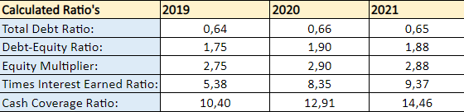

Total Debt ratio refers to the extent that a company possesses financial leverage. This is measured as a ratio of total debt to total assets. We can interpret this total debt ratio as how many owned assets are financed by debts (Hayes, What Is The Debt Ratio, 2022).

The Equity Multiplier can be considered as an indicator that shows risk for a company’s (future) shareholders. It shows us how many of a company’s assets are financed by stockholder’s equity, instead of debt (Ganti, 2022).

Times Interest Earned ratio (TIE) indicates the ability to pay for its made debt. A strong TIE shows that a company, after it has paid its debt, is able to keep on investing in itself (Chen, Times Interest Earned Ratio: What It Is, How To Calculate TIE, 2022).

At last but not least, the Cash Coverage Ratio. This ratio shows how strong a company is in paying their interests and whether it has sufficient money present to create profit’s (Girsch-Bock, 2022).  
We interpret this data as strong. We can observe a debt ratio that increases by 0.01, in other words this can be read as a minimal increase in Walmart debts. As the Debt-Equity ratio increases with a strong 0.13, this means that Walmart’s Equity most definitely increased more than the 0.01 debts.  
The equity multiplier decreased, this as well is considered positive as this reduces Walmart’s dependance on investors (TEAM, 2022). The TIE and the Cash Coverage Ratio increase as well, which is considered (again) as a positive development.

Turnover ratios  
A turnover ratio represents the amount of assets or liabilities that a company replaces in relation to its sales (Bragg, 2022). This is a useful and efficient tool due to the fact that it helps a business to analyze how it utilizes its assets.  
A high *asset* turnover ratio is usually considered positive as it insinuates that receivables are collected quickly, a company’s fixed assets are strongly utilized, and small to little excess inventory is kept.  
On the other hand, a low *liability* turnover ratio refers to a healthy situation as this means a company is taking its longest possible time to pay its suppliers. By doing so they keep cash longer in their possession (Bragg, 2022).

|  |  |  |  |
| --- | --- | --- | --- |
| **Ratios** | **2019** | **2020** | **2021** |
| Inventory turnover | 8,70 | 8,88 | 9,35 |
| Days' Sales in Inventory | 41,94 | 41,10 | 39,03 |
| Receivables Turnover | 81,22 | 83,38 | 85,21 |
| Days' Sales in Receivables | 4,49 | 4,38 | 4,28 |
| Total asset turnover | 2,33 | 2,22 | 2,20 |

To zoom in somewhat deeper in the different (turnover) ratios and what they mean, we have established a brief explanation about them.  
Inventory turnover shows the level of inventory that must be kept to aid a certain amount of sales.  
Days’ Sales in inventory is a financial ratio that shows us an indication of the average time it takes a company to sell its inventory. This includes unfinished goods (Hayes, Days Sales Of Inventory (DSI): Definition, Formula, Importance, 2022).  
Receivables turnover measures the period of time it takes for a company to collects its accounts receivables.  
Days’ Sales in receivables measures the average number of days it takes to collect on receivables (n.d., 2022).  
As can be seen, these two ratio’s share a similar pattern and are quite comparable. There is a slight difference to be noted that is that Days’ Sales in receivables measures the total of collected receivables as that the Receivables turnover ratio shows this over a period of time. This means that in the Receivables turnover ratio it could occur that not all receivables are received.  
Total asset turnover ratio measures how efficient a company is in generating sales based upon its assets  
(Margaret James, 2022).

We interpret this data as highly positive. All but two ratio’s increased in these 3 years.  
Days sales in receivables’ and total asset ratio decrease somewhat. As well ‘Days sales in inventory’ ratio decreases. However, this is positive as the lower this ratio’s gets the more profit Walmart will produce.

Profitability ratios  
Profitability ratios are mostly used to compare one firm's profitability to another. Simply, the higher the rate the better the company is doing. It shows the ability to generate profits from its operating activities. In this case Walmart had steep growth from 2019 to 2020 at the average of 114%, however, the ratios have dropped in 2021, but stood higher than 2019.

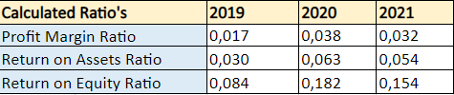

Profit margin ratio calculates the percentage of money left after all taxes and liabilities were paid. This rate is used to determine a company’s abilities to convert sales into net income. The ratio is very important to the investors and creditors, where they can estimate if the company is able to pay dividends and debts (N.d., 2022).

Return on assets ratio(ROA) determines the company’s profitability over its total assets. Usually, this ratio is used to estimate company’s efficiency. In other words, it shows how efficiently a company does its activities (Hargrave, 2022).

Return on equity ratio(ROE)and the ratio above are used to estimate it’s efficiency. Opposite than the previous one, this ratio uses Total equity as the denominator. Usually, the given ratio is compared to the industry’s average ratio. It determines how good or bad a company is generating income from its equity financing (Fernando, Return on Equity (ROE) Calculation and What It Means, 2022).

Market value ratios  
Market value ratios show how well, or poorly, a company’s shares are performing in public markets. It gives an indication of stocks that might be undervalued or overpriced. While Walmart’s share price in public exchange markets is more than three times higher than its book value. In the last 3 years, Walmart’s Earnings Per Share have doubled since 2019, this means that their Net Income has doubled in the last 2 years.

|  |  |  |  |
| --- | --- | --- | --- |
| **Ratios** | **2019** | **2020** | **2021** |
| EPS | 2,32 | 5,25 | 4,80 |
| Price-Earnings Ratio | 41,26 | 21,87 | 29,38 |
| Market-to-Book Ratio | 3,46 | 3,99 | 4,53 |

Earnings per share (EPS)is a widely used ratio to understand a company’s growth over outstanding shares. It is basically the net profit divided by shares outstanding, and the number indicates how good or bad a company does its activities. The ratio is mostly used to estimate the organization’s value in the market. By using this ratio, it is possible to compare a company’s growth to its competitors (Kindness, 2022).

Price-Earnings Ratio (P/E ratio)to understand this ratio, the reader must understand its purpose. That being said, the rate is used to evaluate stock price in the market, however, the company might be over/under valuated compared to its competitors. It is calculated by dividing stock’s price by EPS.   
As higher the number is, the higher growth can be. This is one of the most important ratios for possible investors (Murphy, 2022).

Market-to-Book Ratio, simply this ratio determines and realizes a company’s book value to the market value. Which compares growth in the public market and company’s ledger value (Kenton, 2022).

## Comparison with main competitors

**Average ratios within main competitors in the industry**

|  |  |  |  |
| --- | --- | --- | --- |
| Average Ratios | 2019 | 2020 | 2021 |
| Current ratio | 0.949 | 1.002 | 1.026 |
| Quick Ratio | 0.470 | 0.557 | 0.566 |
| Cash Ratio | 0.262 | 0.343 | 0.275 |
| Total Debt Ratio | 0.571 | 0.686 | 0.695 |
| Debt-Equity Ratio | 1.101 | 1.272 | 1.396 |
| Equity Multiplier | 2.664 | 3.214 | 3.350 |
| EPS | 4.593 | 6.242 | 8.313 |
| Price-Earnings Ratio | 43.712 | 39.896 | 34.133 |
| Market-to-Book Ratio | 7.173 | 9.117 | 8.992 |
| Profit Margin Ratio | 0.031 | 0.041 | 0.049 |
| Return on Assets Ratio | 0.060 | 0.072 | 0.087 |
| Return on Equity Ratio | 0.152 | 0.232 | 0.304 |

In order to understand and realize Walmart’s position in the market, the same ratios had to be calculated for the competitors as well, and the total average represents the market average ratio of each category. The main competitors in the same market as Walmart are, Costco, Amazon, and Target. Very important to mention, that because of Covid-19 the markets were highly affected as well. (See appendix A)

## Liquidity ratios

Speaking in general, Walmart is wealthy company and has relatively high ratios in this section, however, the competitors in this category are doing better. On the other hand, Walmart is not that far aways from average, the new situation will be visible after all 4 companies will release their annual reports for 2022. As closer the ratio is to 1, the better the company performs with its liquidity. Mainly because of covid, Walmart didn’t grow at the willing pace in 2020. On the other hand, 2021 was way better for Walmart, because the ratios grew at a good pace. The average market growth rate of the Current Ratio was 2%, while Walmart in the same year grew by 22%. (See appendix A)

## Financial leverage ratios

The importance of these ratios is that it shows solvency and capital structure of a company. Simply, it shows, how company can utilize money, that has been borrowed. (Team, CorporateFinanceInstitute, 2022) Walmart’s Total Debt, and Debt-Equity ratios are almost at the average of the market, which means that utilization of company’s assets are at the average to the market. The only one exception is equity multiplier, which shows assets utilization over equity instead of debt. The market’s average of Equity Multiplier in 2021 was 3.350, while Walmart’s same ratio is 2.885, which means that it is 15% below the market’s average and 31% below Target’s Equity Multiplier (see appendix A).

## Market value ratios

Market value ratios are ratios that determine the position of the company within its market. For example, Market-to-book value determines how much the company is under/overvalued in relation to the book value and market value of the company. The average of all 3 years of this ratio is 4.172 for Walmart, while the market average for the same period is 8.428, which means that 2.02 times lower than the market’s average. The price-earnings ratio for Walmart in 2021 was 29.381, which means that it is close to the market’s average of 34.133. Compared to 2020 EPS of Walmart decreased, which gives the assumption that Walmart lost a small part of the market share in 2021 (see appendix A).

## Profitability ratios

Profitability ratios evaluate a company’s ability to gain profits from its services/sales/operations, which means that a higher rate is always in favor of the company and its ability to attract investors. A high rate indicates that the company is doing well. For example, Profit Margin Ratio for Walmart in 2019 was 0.017 and in 2020 it grew to 0.038, which indicates that Walmart doubled this ratio over the year, however, the market’s average in 2020 was 0.041, which tells that Walmart was performing below market average. While in 2021 it decreased to 0.032 and was close to the 2019 market average of 0.031. The return on Equity ratio in 2021 was 0.154, which is more than twice lower than the market average of 0.304, which indicates that Walmart performed below investors’ expectations after the 2020 fiscal year ended. Return on assets is in a very similar situation, however, this ratio is closer than the previous one (see appendix A).

## Conclusions

Based on collected information, in most cases Walmart is performing below market average, therefore, it shows stable growth in every category of ratios, since Covid affected the market in 2019. Turnover ratios are not mentioned in this section of the report, because of too many outliers, which causes difficulties to indicate a real average of the market.

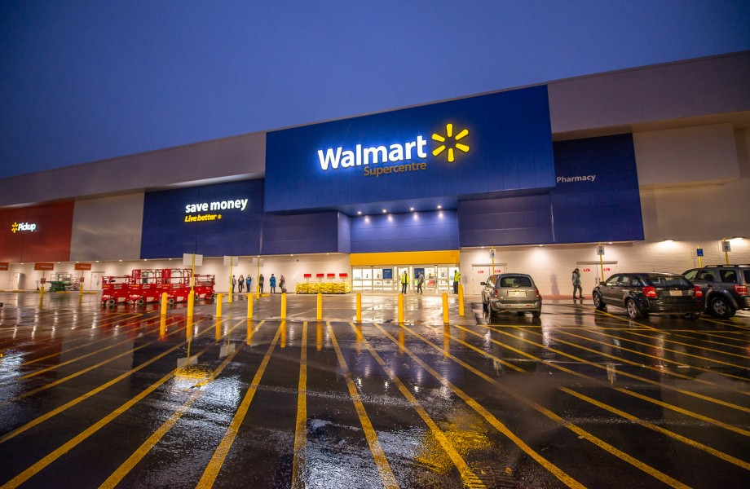

Common-size analysis

To conclude the Financial Statement Analysis, we have analyzed Walmart’s Balance sheets and Income statements via a vertical common-size analysis.

A common-size analysis stands for a technique that can be used to express a company’s financial statements in the form of a percentage. This percentage is calculated based upon dividing the components of the financial statements through a base item, this will accordingly by multiplied by 100 to represent the percentage (Team, CorporateFinanceInstitute, 2022).  
To make this more concrete, for the common-size analysis of the Balance sheet, all the individual components have been divided by the Total Assets (base) on the assets side of the balance sheet, and Total Liabilities + Equity (base) on the liabilities and equity side of the balance sheet.  
For the income statement this base was the total revenues, all components have been divided by the total revenues.

The interpreting of the below found common size analyzed balance sheet can be found on the next page.

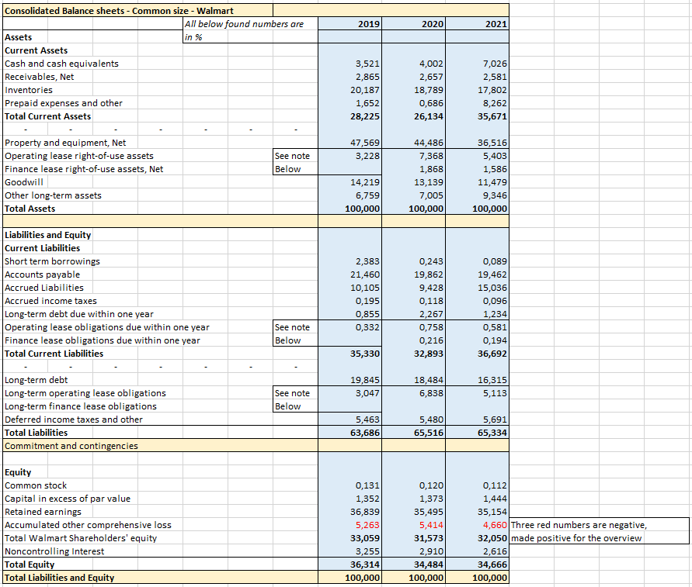  
(Walmart, 2019 Annual Report, 2019) (Walmart, 2020 Annual Report, 2020) (Walmart, 2021 Annual Report, 2021)*’See note below’ can be found in the excel – calculation’s file, as well added with this report.

If we sum up the long-term assets, we observe that this consists of 71.775% (2019) of Walmart’s assets.  
If we add up the inventory as well (current assets), we get a number of 91.962%.   
This shows us that more than 90% of Walmart’s assets consist of its long-term investment and its inventory combined.   
The fact that 20,187% is the inventory is to be expected, Walmart is a company that presents itself as a one-stop shop (highly differentiated inventory). A (reasonable) high level of inventory is required to keep its shops filled and its customers served.  
The other 71.775% in 2019, 73.886% in 2020 and 64.33% in 2021 tells us that Walmart is investing more in its long-term activities. To make this concrete we can see that the biggest amount of these percentages belongs to Walmart’s investment in *property and equipment*.   
Walmart has 10,500 stores in the US and every store is, accordingly, filled with equipment (computers, shelves, advertisement boards, etc.). Every store being filled up weekly by trucks to maintain inventory.  
These are examples of its *property and equipment* that illustrate why these numbers are significant in their proportions.

On the liabilities side of the balance sheet we can see that 21.46% (2019) comes from its accounts payable (current liabilities). This shows us that Walmart is paying its suppliers after delivery or after a certain period of time on a contractual basis. For instance once a month after the suppliers let Walmart knows how much work has been done and has to be paid. 2020 and 2021 stays fairly the same to 2019.  
The second significant factor, in its *liabilities and equity,* is the shareholders’ equity, a total of 33.059% in 2019, 31.573% in 2020 and 32.05% in 2021. We can observe a strong and fairly high profit margin ratio, as well can we see strong TIE and Equity multiplier ratio. These stable and strong ratios are well aligned with a shareholders’ equity of over 30%. This data therefore is logical and to be expected.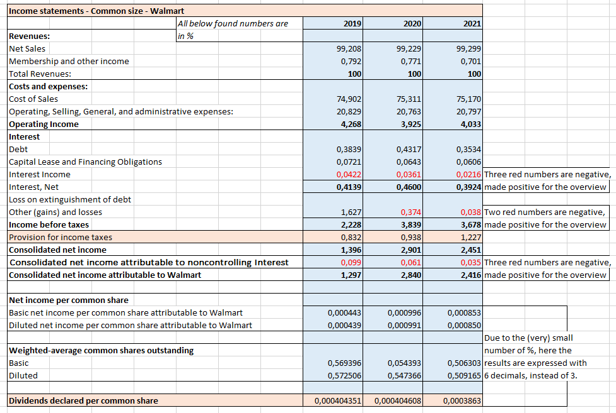  
(Walmart, 2019 Annual Report, 2019) (Walmart, 2020 Annual Report, 2020) (Walmart, 2021 Annual Report, 2021)

Above we can see the common sized version of Walmart’s income statement.  
In the excel file that shows the made calculations you can see a net sales in 2019 of 510,329,000

In the common-size income statement we can see that three times +99% of its revenues come from net sales. To put in in perspective, these three revenues are $510,329,000 (2019), $519,926,000 (2020) and $555,233,000 (2021). These numbers of revenue are significantly huge. Walmart is generating half a billion of revenues annually. The interesting part now is to find out what part of this revenues turns into its profit.  
We can see that three times its *cost and expenses* is of above 95% (cost of sales + operating, selling, general, and administrative expenses). $492,448,000 for 2019, $503,396,000 for 2020, and $536,603,000 for 2021. On one side Walmart is generating tremendously high revenues, but this does not comes at low costs. When we look further down the income statement we note other cost posts that are of smaller size but nevertheless nibble down the profit more. At the end, Walmart earns a profit of in between $1,200,000 and $2,800,000. It goes without saying this is a profit to be proud of for a company of this size. Still, there would be many to gain if Walmart would or could be able to cut down on its costs. If 1% of its costs could be cut Walmart would have an increase in profit of $5,000,000.

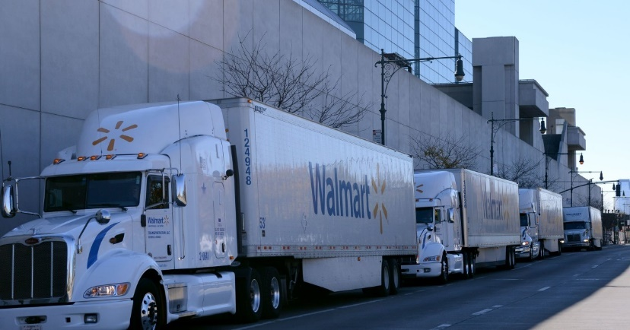

# Capital structure analysis

Capital structure is a mixture of various external funds such as shareholders’ equity, preferred stock and debt. Capital structure can always be seen in the company’s balance sheet. It is as well a mixture of a company’s debts and equity, to be used in the assets and operations. The most recent data available about Walmart’s capital structure is a long-term debt of $167,530,000, a shareholder's equity of $80,120,000 and a debt-to-equity ratio of 2.09 (Marcotrends, n.d.) (Lightspeed, 2021).

## The cost of equity

In simple words, the cost of equity is the return the firm pays to its equity investors and shareholders. A firm needs to acquire capital from others to operate and grow. (the complete toolbox for investors, 2022)

Cost of equity: (dividends per share/ current stock price) + dividend growth rate =

The cost of equity is (TEAM, 2022)the rate of return a company pays out to equity investors.

The annual report concludes that the cost of equity for 2020 is $1,324,000, the cost of equity % is 7.9%.

It is calculated by using the capital asset pricing model (CAMP)

3.575% + 0.53 x (13.2% - 3.575%) (Yahoo Finance, 2022).

## The cost of debt

The cost of debt is the effective interest rate that a company pays on its debts according to (Hayes, Cost of debt, 2022).

The cost of debt of Walmart is estimated to be $34.86 million dollars in 2022, a decline of 13.17% from 2021 (Marcotrends, n.d.). Total interest/total debt =

## The Firm’s WACC

To calculate the WACC, we must first understand what it is and what information is required to calculate it.

WACC is an abbreviation for Weighted Average Cost of Capital. It is mostly used to experiment whether a company's return on investment can exceed or be met with an asset or cost of invested capital. It is used in financial modeling, and it is also known to be the discount rate for the present value of Walmart.

The formula used for calculating the WACC is as follows

**WACC: (E/V x Re) + [(D/V x Rd) x (1-T)] =**

So, if we apply this formula on the data related to Walmart we can start and calculate the WACC.  
WACC: 7,9% x [($413,2B/$247.66B)] + [4% x $38.45B/247.66B)] + [0 x (26.75/247.66B)] = *6,08%.*

The main competitors of Walmart plus their according data can be found below.  
We have calculated the cost of equity, cost of debt and the WACC, just as we have done that for Walmart above. As well have we added the belonging interpretation of each of the competitors.

**Target**

Target’s WACC is much higher by 2.32%, which means that Target has a higher risk associated with the firm’s operations.

The cost of equity: 9.15%

The cost of debt: 5.1%

WACC: 8.4%

In conclusion,

Target’s WACC is one of the highest among the competitors and could risk not only their firms' operations but also the risk of an investment, which could result in investors demanding a return.

**Amazon**

Amazon's WACC is higher than Walmart and targets which means that the risk is significantly higher that is associated with the firms' operations

The cost of equity: 9.65%

The cost of debt: 4.65%

WACC: 9.30%

In conclusion,

Amazon has the highest cost of equity among the competitors, which means that their risks within the firms' operations are the highest. This means that the risk of an investment increases and the investors could demand an additional return.

**Costco**

Costco (Yahoo Finance, 2022)'s WACC is the one of the lowest out of all the competitions and it shows that it has no risk in their firms' operations and the highest market value of the companies.

The cost of equity: 7.75%

The cost of debt: 4.45%

WACC: 7.75%

In conclusion,

Costco has the WACC of 7.75%, their cost of debt is the lowest among of the competitors. The results means that Costco has a low market value while having low debt costs than to earning over your investments.

Figure 2.1 Cost of equity Walmart and competitors

## Comparison

The comparison, in percentages, of the WACC between Walmart and its competition can be found below.

|  |  |  |  |  |  |
| --- | --- | --- | --- | --- | --- |
| Capital  Components | Walmart | Target | Amazon | Costco | Industry average |
| Cost of Equity | 7.9% | 9.15% | 9.65% | 7.75% | 8.61% |
| Cost of debt | 5.46% | 5.1% | 4.65% | 4.45% | 4.05% |
| WACC | 6.08% | 8.4% | 9.30% | 7.75% | 7.88% |

## Preferred method of financing

The preferred financial method for Walmart is through debt, it lowers the interests’ rate, and it helps continually to grow the net profit. By lowering the interest rate, managers can oversee how they benefit from the loans that can be deducted. By loaning a huge amount of sum could deduct the taxes for Walmart. The tax deductions are as business expenditures of the company loans. (Way, 2019)

The advantage of this method is that the predictability of payments is high, especially when the loan payments are easy to forecast. With loaning money instead of selling your shares, you don’t lose the company ownership. Paying back in a monthly instalment leaves room for more investment and or their business wouldn’t be influenced as much as one big decrease at ones.

## Walmart’s advantages – using debt

Even though it is identified as a liability, debt has several advantages for a company the size of Walmart when used properly. When a firm has debt, it can help keep profits within a company and usually helps to secure tax savings, in other words they are ongoing financial liabilities. Debt has interest payable, which can be deducted from income, lowering tax costs further (Way, 2019).

Using debt as a way of financing might be profitable due to the dividend payments to shareholders, the payments in the future would be higher than interest rates to be paid for debt. (Lightspeed, 2021)

Financing through equity would require Walmart to increase the number of shares outstanding. This could cause unhappiness among major shareholders as they would be losing their influence on the company, especially because of Walmart using voting system.

# Future investments

Walmart, when planning its future investments, focuses on higher efficiency, diversification and addressing social and environmental problems. Walmart is soon opening new consolidation centers which would help the supply chain become more efficient. Walmart also invests in its fulfillment network centers, with a focus on improving the process, training, and equipment. The company also expands its brand by acquiring new companies and giving customers an even wider range of products. The company pledges to create job possibilities for American citizens and to be more sustainable; by creating facilities that are100% powered by renewable energy sources, electrification of the fleet and lower-impact cooling systems.

When analyzing future investments, it is possible to come up with current/future trends inside the industry. One of the trends would be improving the supply chain efficiency, new consolidation centers are being built by Walmart to ensure lower costs and lower C02 emissions. Walmart is also investing in the fulfillment industry which means that it acts as a middleman between very small companies taking care of their marketing and logistic needs, this trend has been popular for some time already (e.g., Amazon). Another trend in the industry would be diversification with Walmart acquiring new businesses and selling their products on their website. Walmart also invests in trends that are very broadly known: sustainability and social well-being (developing-our-fulfillment. z.d.).

Looking at the investments it is possible to understand what factors are important for Walmart when choosing them, especially while comparing them with trends in the industry. Appraising process of the company considers factors like lower costs (through more efficient supply chain), new revenue streams (through differentiation) and trends that are expected from the public and/or government like better sustainability and social well-being (Investing in American Jobs. z.d.).

# References

Banerjee, P. (2022, 09 26). *Importance of Ratio analysis*. Retrieved from WallstreetMojo: https://www.wallstreetmojo.com/importance-of-ratio-analysis/#:~:text=Ratio%20analysis%20is%20important%20for,and%20proper%20utilization%20of%20funds.

Bragg, S. (2022, 05 24). *Turnover Ratios*. Retrieved from AccoungTools.com: https://www.accountingtools.com/articles/what-is-a-turnover-ratio.html

Chen, J. (2022, 08 18). *Corporate Governance Definition: How It Works, Principles, and Examples*. Retrieved from Investopedia: https://www.investopedia.com/terms/c/corporategovernance.asp

Chen, J. (2022, 04 04). *Times Interest Earned Ratio: What It Is, How To Calculate TIE*. Retrieved from Investopedia: https://www.investopedia.com/terms/t/tie.asp#:~:text=A%20company's%20TIE%20indicates%20its,total%20interest%20payable%20on%20debt.

Fernando, J. (2022, 07 11). *Current Ratio Explained With Formula And Examples*. Retrieved from Investopedia: https://www.investopedia.com/terms/c/currentratio.asp

Fernando, J. (2022, 06 27). *Return on Equity (ROE) Calculation and What It Means*. Retrieved from Investopedia: https://www.investopedia.com/terms/r/returnonequity.asp

Folger, J. (2022, 01 12). *How Do The Current Ratio And Quick Ratio Differ*. Retrieved from Investopedia: https://www.investopedia.com/ask/answers/062714/what-are-main-differences-between-current-ratio-and-quick-ratio.asp#:~:text=The%20quick%20and%20current%20ratios,as%20part%20of%20current%20assets.

Ganti, A. (2022, 09 29). *What Is The Equity Multiplier? Definition, Formula, and Examples*. Retrieved from Investopedia: https://www.investopedia.com/terms/e/equitymultiplier.asp#:~:text=The%20equity%20multiplier%20is%20a,by%20its%20total%20shareholders'%20equity.

Girsch-Bock, M. (2022, 08 05). *Understanding the Cash Coverage Ratio and How To Calculate It*. Retrieved from Fool: https://www.fool.com/the-ascent/small-business/accounting/articles/cash-coverage-ratio/#:~:text=The%20cash%20coverage%20ratio%20is%20an%20accounting%20ratio%20that%20is,interest%20and%20turn%20a%20profit.

Hargrave, M. (2022, 06 14). *Return on Assets (ROA): Formula and 'Good' ROA Defined*. Retrieved from Investopedia: https://www.investopedia.com/terms/r/returnonassets.asp

Hayes, A. (2022). *Cost of debt*. Retrieved from investopedia: https://www.investopedia.com/terms/c/costofdebt.asp

Hayes, A. (2022, 05 04). *Days Sales Of Inventory (DSI): Definition, Formula, Importance*. Retrieved from Investopedia: https://www.investopedia.com/terms/d/days-sales-inventory-dsi.asp

Hayes, A. (2022, 03 28). *What Is The Debt Ratio*. Retrieved from Investopedia: https://www.investopedia.com/terms/d/debtratio.asp#:~:text=The%20term%20debt%20ratio%20refers,that%20are%20financed%20by%20debt.

Kenton, W. (2022, 05 13). *Book-to-Market Ratio Definition*. Retrieved from Investopedia: https://www.investopedia.com/terms/b/booktomarketratio.asp

Kindness, D. (2022, 08 23). *Earnings Per Share (EPS): What It Means and How to Calculate It*. Retrieved from Investopedia: https://www.investopedia.com/terms/e/eps.asp

Lightspeed. (2021, March 23). *Advantages and disdvantages of debt financing*. Retrieved from lightspeed: https://www.lightspeedhq.com/blog/advantages-of-debt-financing/

Marcotrends. (n.d.). *Walmart long term debt* . Retrieved from Marcotrends: https://www.macrotrends.net/stocks/charts/WMT/walmart/long-term-debt

Margaret James, A. H. (2022, 06 15). *Asset Turnover Ratio Definition*. Retrieved from Investopedia: https://www.investopedia.com/terms/a/assetturnover.asp#:~:text=The%20asset%20turnover%20ratio%20measures%20the%20efficiency%20of%20a%20company's,by%20the%20average%20total%20assets

Murphy, C. B. (2022, 09 18). *Using the Price-to-Earnings Ratio and PEG to Assess a Stock*. Retrieved from Investopedia: https://www.investopedia.com/investing/use-pe-ratio-and-peg-to-tell-stocks-future/#:~:text=The%20P%2FE%20ratio%20is,500%20Index%20stocks%20is%2025

n.d. (2022, 12 03). *Accounts Receivable Turnover Ratio vs Days Sales Outstanding: What's the Difference?* Retrieved from Causal: https://www.causal.app/whats-the-difference/accounts-receivable-turnover-ratio-vs-days-sales-outstanding#:~:text=The%20key%20difference%20between%20the,takes%20to%20collect%20on%20receivables

N.d. (2022, 12 01). *Profit Margin Ratio*. Retrieved from MyAccountingCourse: https://www.myaccountingcourse.com/financial-ratios/profit-margin-ratio

Team, C. (2022, 12 01). *CorporateFinanceInstitute*. Retrieved from Common Size Analysis: https://corporatefinanceinstitute.com/resources/accounting/common-size-analysis/

TEAM, C. (2022, Nov 27). *Cost of Equity*. Retrieved from CFI: https://corporatefinanceinstitute.com/resources/valuation/cost-of-equity-guide/

Team, C. (2022, November 26). *https://corporatefinanceinstitute.com/resources/accounting/leverage-ratios/*. Retrieved from corporatefinanceinstitute.com: https://corporatefinanceinstitute.com/resources/accounting/leverage-ratios/

*the complete toolbox for investors*. (2022). Retrieved from finbox.com: The Complete Toolbox For Investors | finbox.com. (z.d.). https://finbox.com/NYSE:WMT/explorer/cost_equity

Walmart. (2019). *2019 Annual Report.* Delaware: Walmart Inc.

Walmart. (2020). *2020 Annual Report.* Delaware: Walmart Inc.

Walmart. (2021). *2021 Annual Report.* Delaware: Walmart Inc.

Way, J. (2019, January 28). *The advantages of using debt as capital structure*. Retrieved from CHRON: https://smallbusiness.chron.com/advantages-using-debt-capital-structure-22011.html

Yahoo Finance. (2022). *Balance sheet*. Retrieved from Yahoo Finance: https://finance.yahoo.com/quote/WMT/balance-sheet?p=WMT

# Appendices

## Appendix A – Market comparison – Financial statement analysis

**2021**



**2020**



**2019**



## Appendix B – Balance Sheets – Financial Statement Analysis

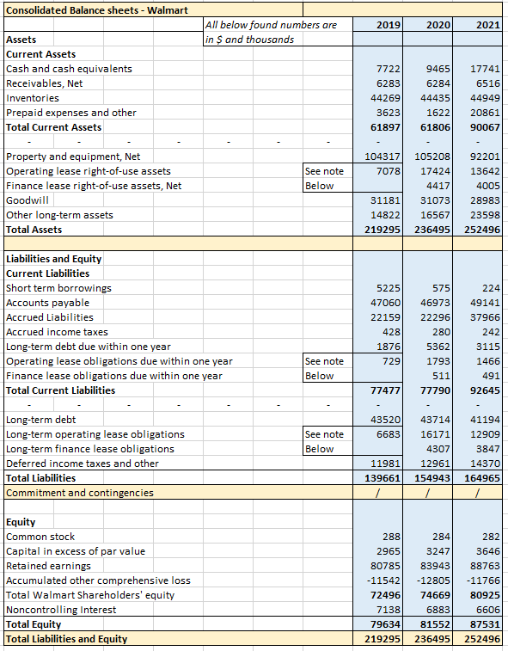

## Appendix C – Income Statements – Financial Statement Analysis

